Project Design Phase-II
Data Flow Diagram & User Stories

Date | 04 February 2026
Team ID | LTVIP2026TMIDS66199
Project Name | TransLingua: AI-Powered Multi-Language Translator
Maximum Marks | 4 Marks

Data Flow Diagrams:
A Data Flow Diagram (DFD) is a traditional visual representation of the information flows within a system. A neat and clear DFD can depict the right amount of the system requirement graphically. It shows how data enters and leaves the system, what changes the information, and where data is stored.

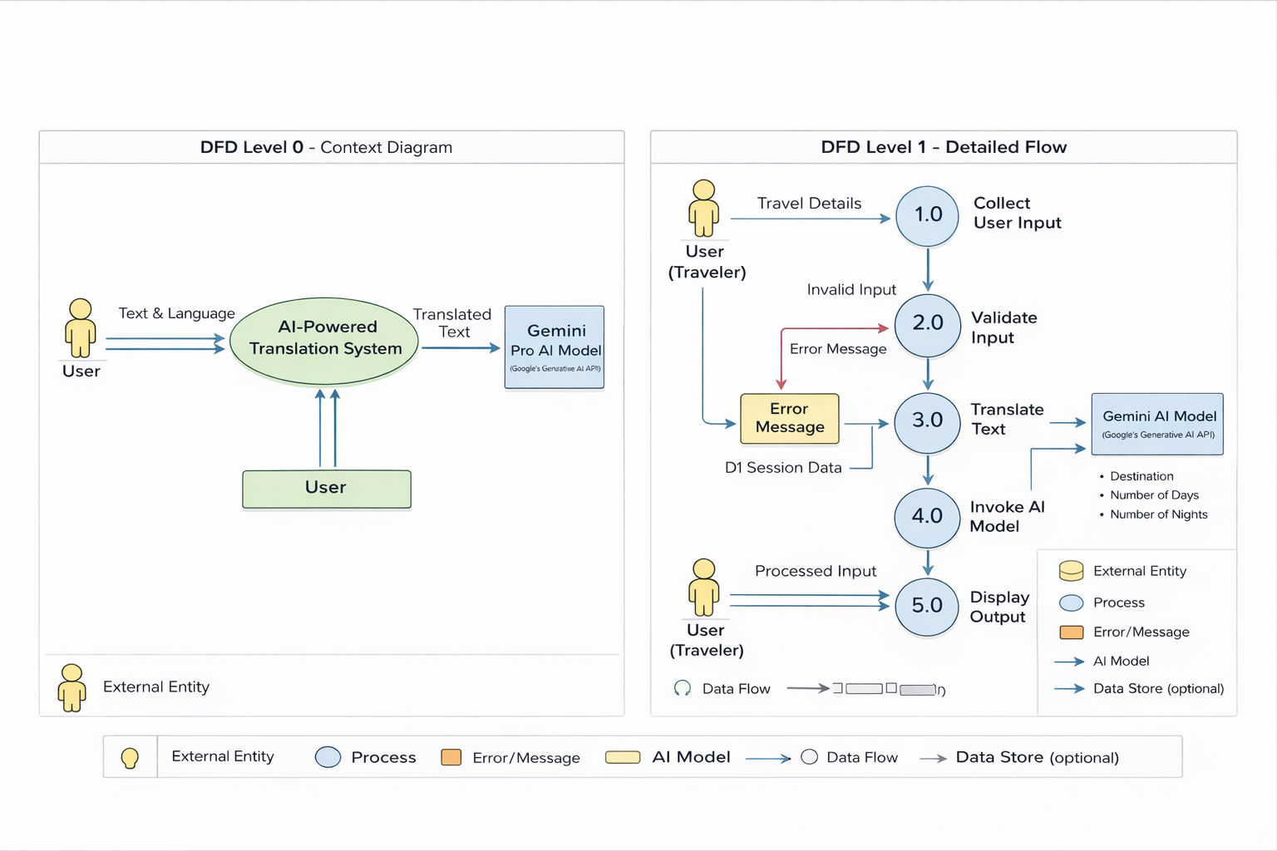

User Stories
Use the below template to list all the user stories for the product.
User Type | Functional Requirement (Epic) | User Story Number | User Story / Task | Acceptance Criteria | Priority | Release
Customer (Web User) | Text Translation | USN-1 | As a user, I can enter text, select source language and target language to translate content. | The system generates accurate translated text based on the selected languages. | High | Sprint-1
Customer (Web User) | Input Validation | USN-2 | As a user, I want the system to validate my text and language selections before translation. | If text is empty or languages are not selected, the system displays an appropriate error message. | High | Sprint-1
Customer (Web User) | AI Integration | USN-3 | As a user, I want the system to use Gemini Generative AI to translate text contextually. | The AI generates context-aware and meaningful translated text. | High | Sprint-2
Customer (Web User) | Output Display | USN-4 | As a user, I want to view the translated text clearly on the web interface. | The translated text is displayed in a readable and properly formatted layout. | Medium | Sprint-2
Customer (Web User) | Error Handling | USN-5 | As a user, I want the system to handle API or runtime errors gracefully. | If an API failure or runtime error occurs, the system shows a user-friendly error message without crashing. | Medium | Sprint-3
Customer (Web User) | Multi-Language Support | USN-6 | As a user, I want the system to support translation between multiple languages. | The system allows selection from multiple languages and performs translation correctly. | Medium | Sprint-3
Customer (Web User) | Performance & Responsiveness | USN-7 | As a user, I want the translation to be generated quickly. | The translation is displayed within acceptable response time (few seconds). | Low | Sprint-3

